Failed parts | Reason for Failed | Result
1008253 | Decolletage part | *
000.199.357V5 | Flat part with bevels/chamfer | *
1009257-01_Default | Error Designer: "No solid data in file" corupted? | *
1023039 | Step-bend part | *
1035892 | Decolletage part | *
1051830-00_Default | Rolled part | *
1067805 | Step-bend part | *
1355_551_0000 | Step-bend part | *
300113634 | Flat part with bevels/chamfer | *
B_Bühler Emblem | Coining | *
B_RFKS-10384-010 | Flat part with bevels/chamfer | *
B_SKRH-11940-001_ST0002421475_01 | Bend part with bevels/chamfer | *
B_SKRH-24343-001_WT0003843339_00 | Bend part with rounded edges | *
B_Senkung | Bend part with sink holes | \
P015731_4020_004_A_12 | Assembly with tubes | *
P015732_0760_003 | Assembly | \
PIECE 5 | Step-bend part | *
PIECE 6 | Komplex bend part | *
PIECE 9 | Step-bend part | *
z20610 | Detected as Flat part, but is Flansch | \
*: Part detected by Unfolder and marked in AutoPart
\: Part NOT detected by Unfolder

1008253
Part is a weld stud and not a sheet metal part. Instapart returns the shape type OTHER which is currently the expected result for such parts. How should such parts be indicated in the .info files?
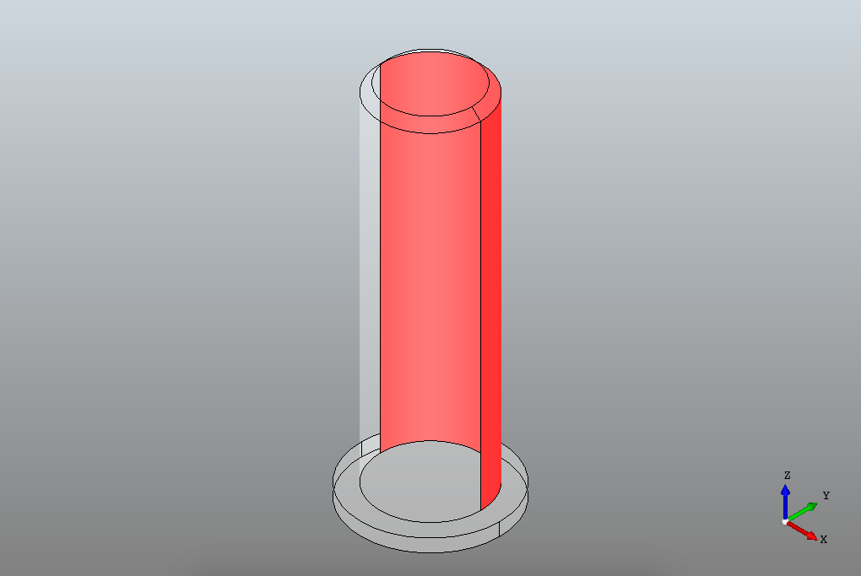

000.199.357V5
The part contains both chamfered edges and a milled step. Currently these features are not supported. We currently indicate internal loops with a chamfer as an extrusion with zheight=0, we can use a more suitable interface if this is added to the Designer DXF spec.
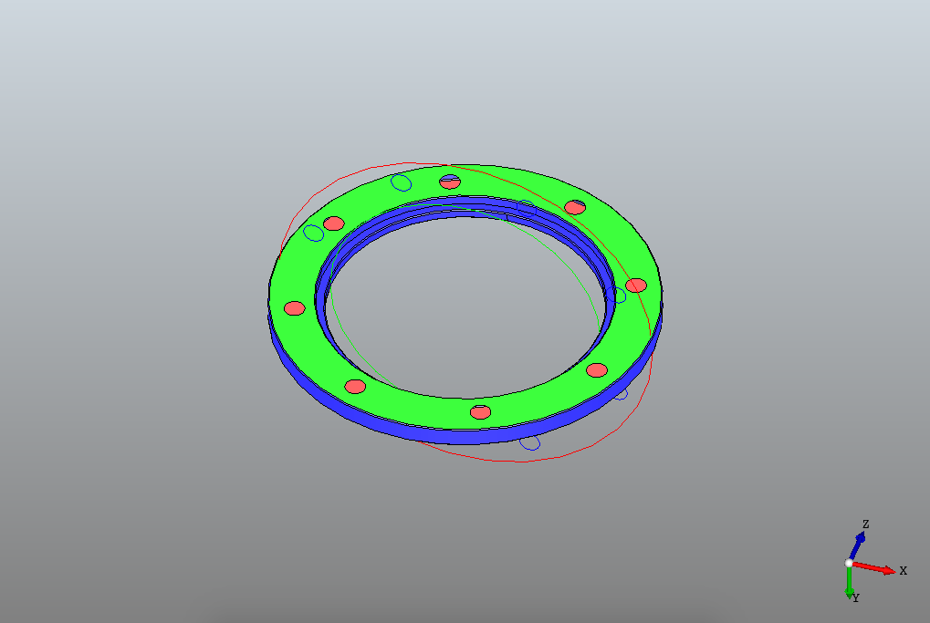

1009257-01_Default
The STEP file contains a correct part Tree but has no geometric information what so ever (as far as I can detect).
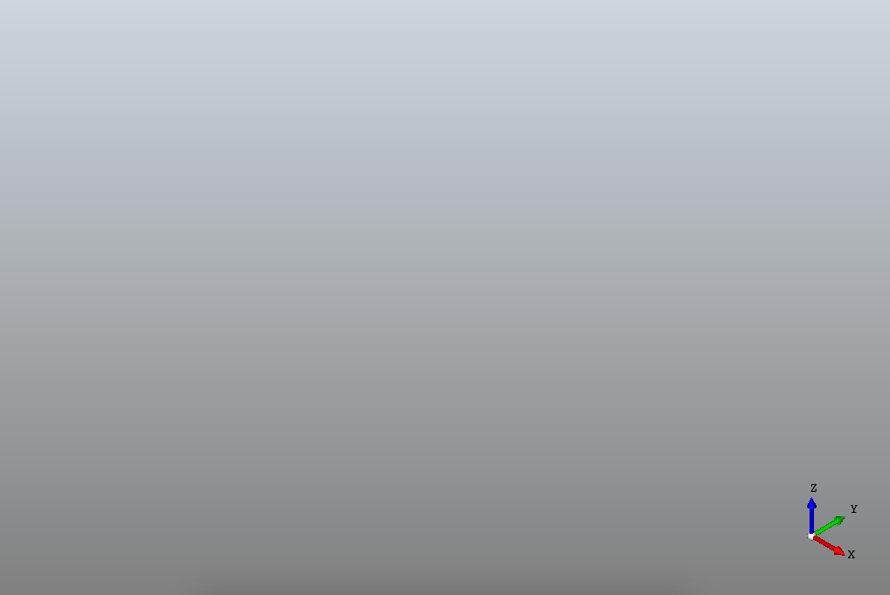

1023039
Part has curved part with a radius that is non-homogenous. Currently this is not supported by Instapart and only “simple” bends with constant radius are supported. Note, that if such a part is drawn as how it would look coming from a press-brake (multiple constant radius bends with flats in between) it should work without a problem.
I can investigate the addition of adding such bends although it quickly becomes ambiguous how to flatten such a part especially if you would like to add bend deductions.
Finally, the part also contains heavy bevels on the edges of the part.
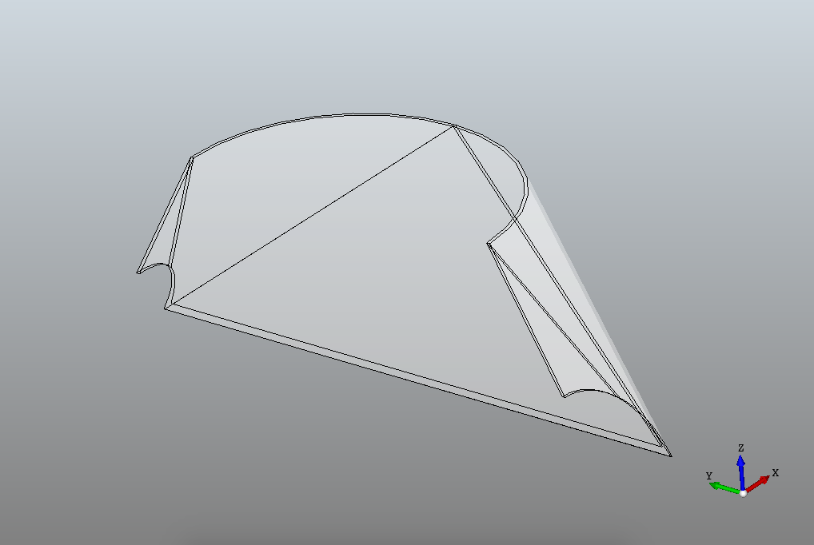

1035892
Similar to 1008253, the part contains a stud instead of a sheet metal part. As such it is returned as a shape of type OTHER.
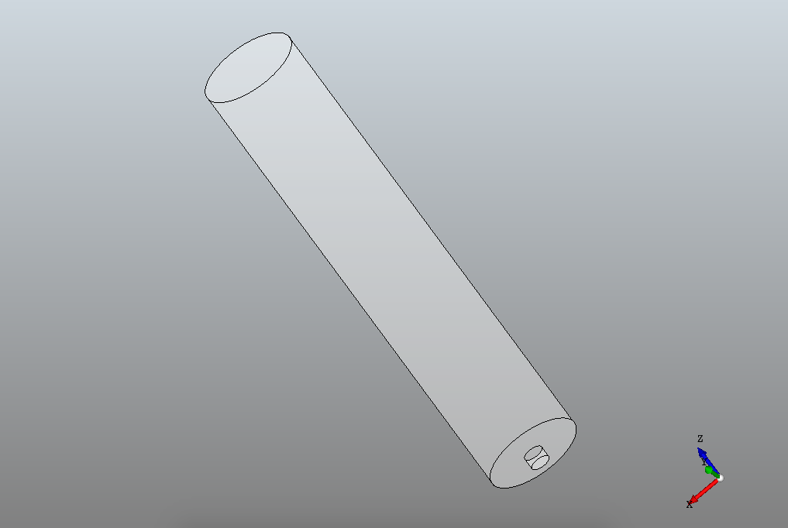

1051830-00_Default
Similar to 1023039, the part has a non-constant radius. This is something that is currently non taken into account by instapart.
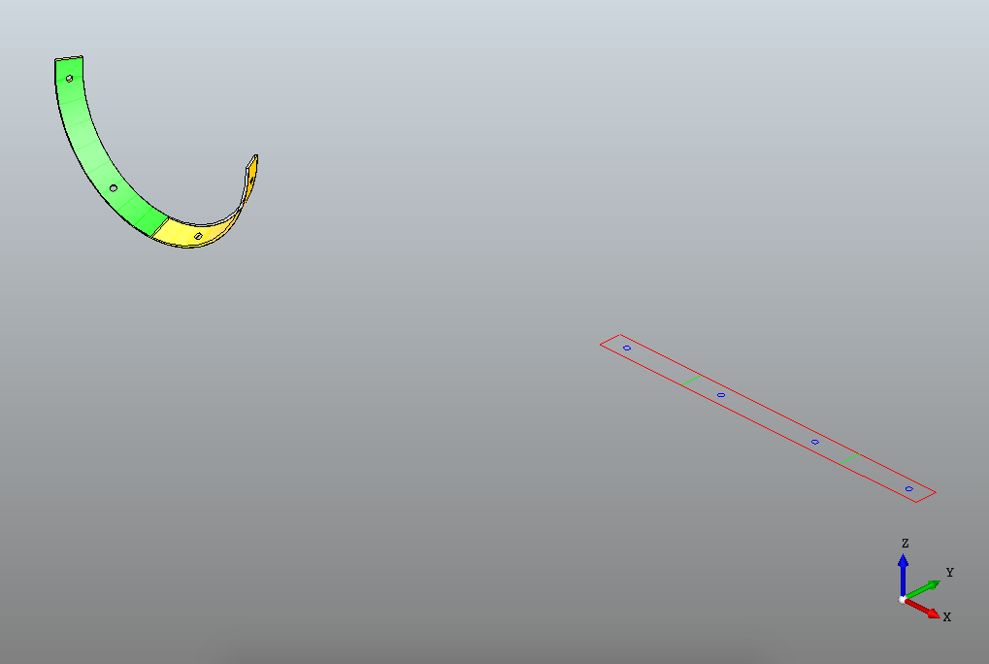

1067805
Similar to 1023039, the part has a non-constant radius. This is something that is currently non taken into account by instapart.
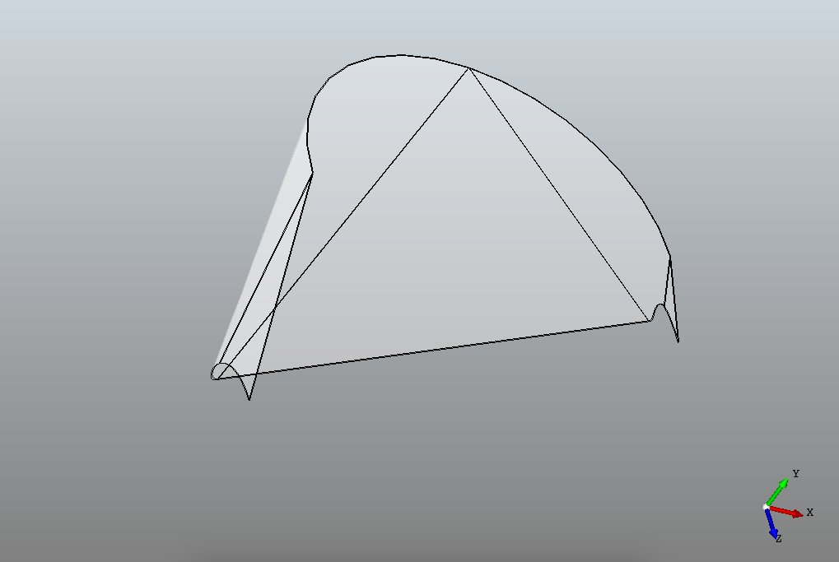

1355_551_0000
Similar to 1023039, the part has a non-constant radius. This is something that is currently non taken into account by instapart.
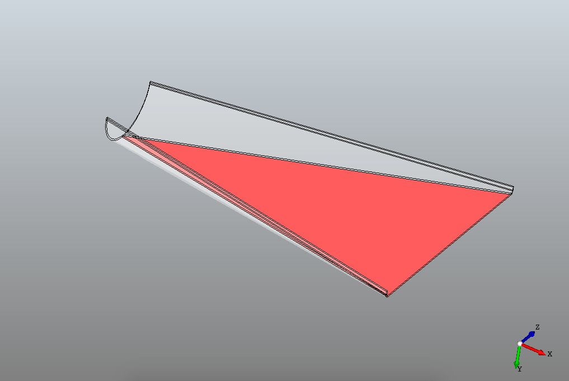

300113634
Part is heavily bevelled at the edges. This is currently not supported by instapart although we can of course discuss what information Bysoft needs to correctly handle these types of parts.
The countersunk circular holes are currently already detected by instapart. An interface should be decided on to return this information to Bysoft. Currently, we return an extrusion with zheight=0.
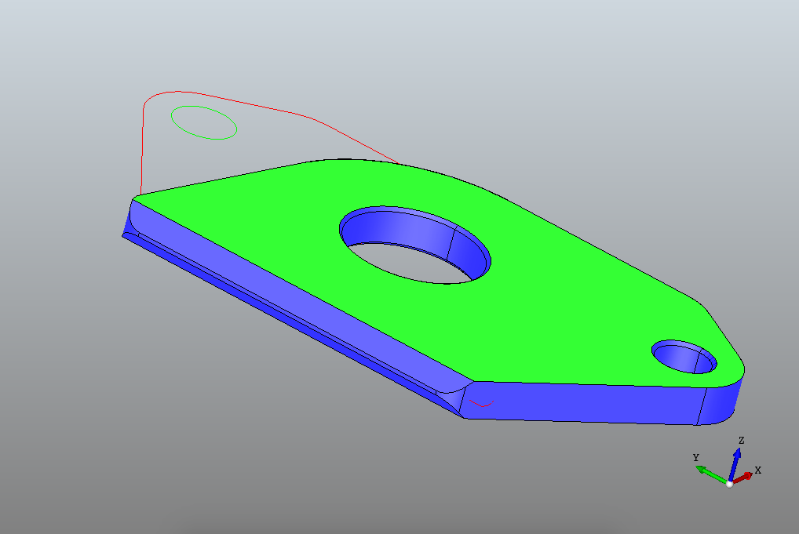

B_Bühler Emblem
Part contains embossings that are currenly returned by instapart as extrusions with zheight=0. On our side we however detect the difference between an embossing and an extrusion and can therefore return this information if we agree upon an interface in the Designer DXF spec.
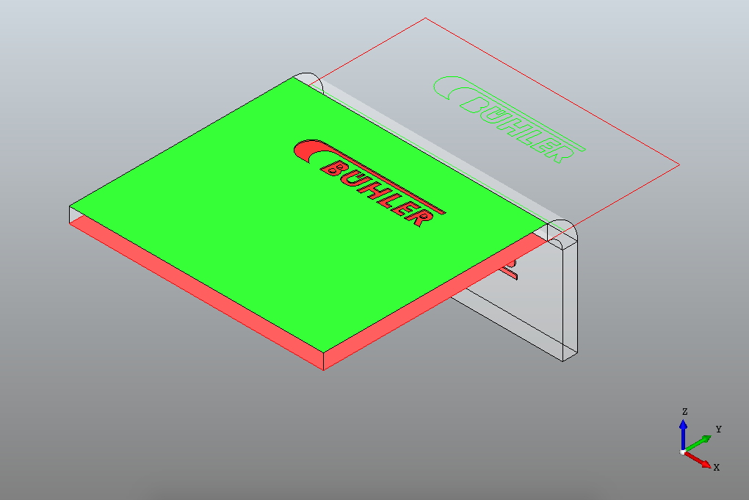

B_RFKS-10384-010
This part has an complex feature milled out from the center of the product. Currently, instapart support embossings fully contained within one face as in B_Buhler_Emblem.
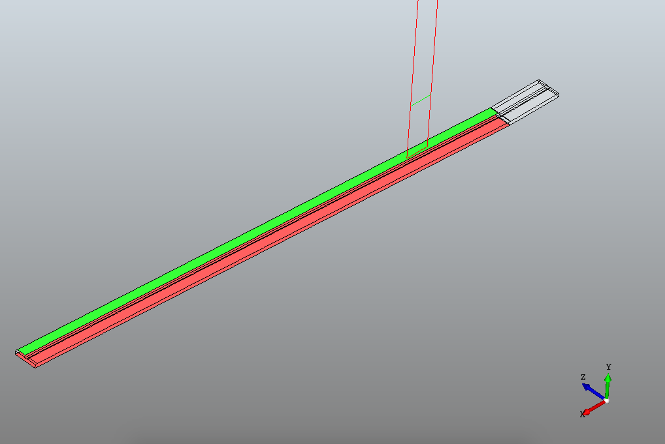

B_SKRH-11940-001_ST0002421475_01
The part contains edge chamfers that are currently not supported. Instapart can detect the angle of an edge (and thus if it is square or chamfered), we would need to discuss how to convey this information to Bysoft to use it in a suitable way.
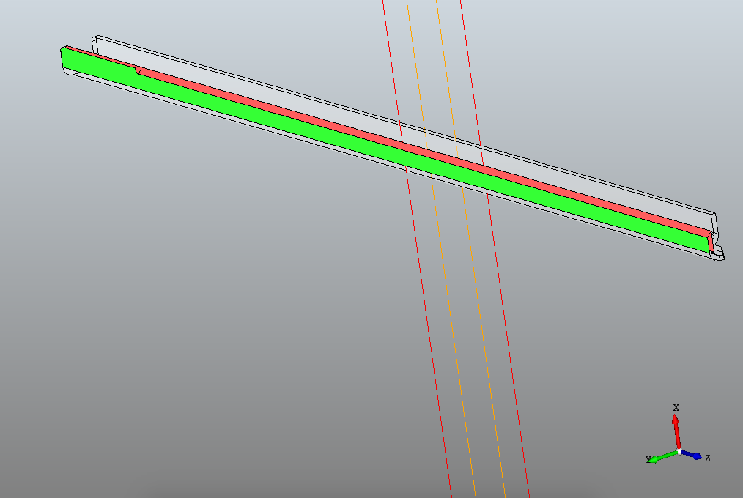

B_SKRH-24343-001_WT0003843339_00
This part is rounded on all sided of the product. Currently the fillets are not supported apart from fillets detected on extrusions.
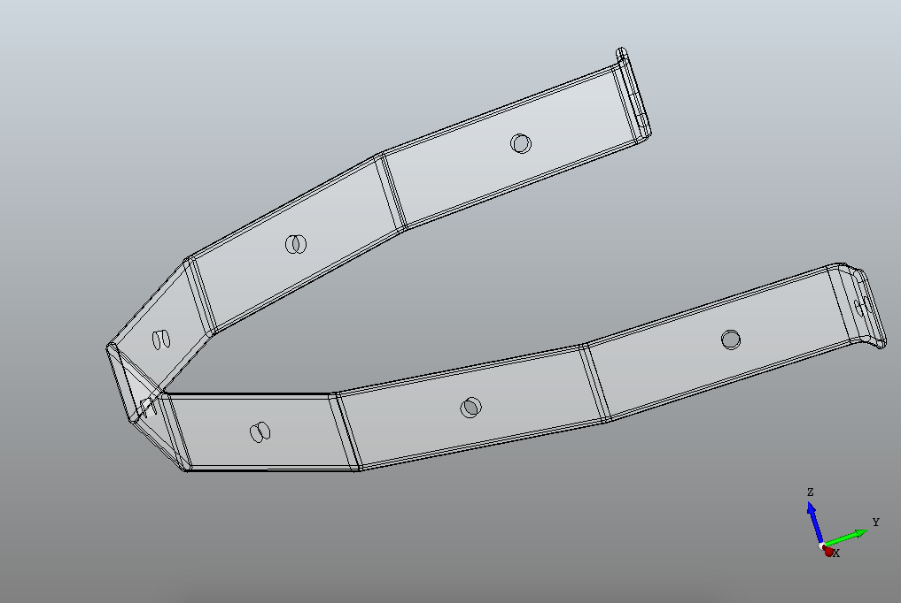
B_Senkung
Part contains two countersunk holes. Interface should be discussed to add support for countersunk holes in designer DXF.
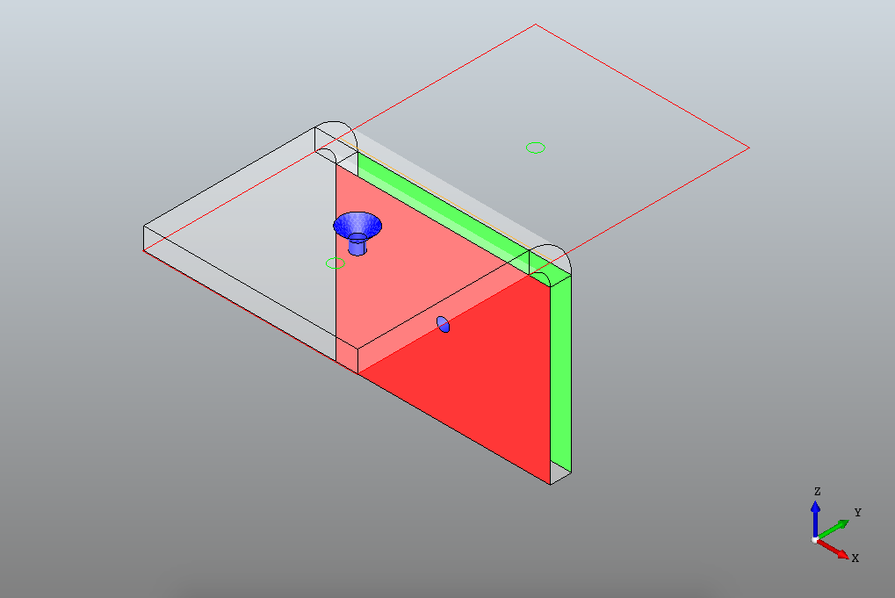

P015731_4020_004_A_12
As described the file contains three rectangular tubes. Currently this feature is not added to instapart. We have worked with the recognition of the tubes in the past if required this is a feature that will have to be further discussed as it will require significant work on the end of SmartPart.
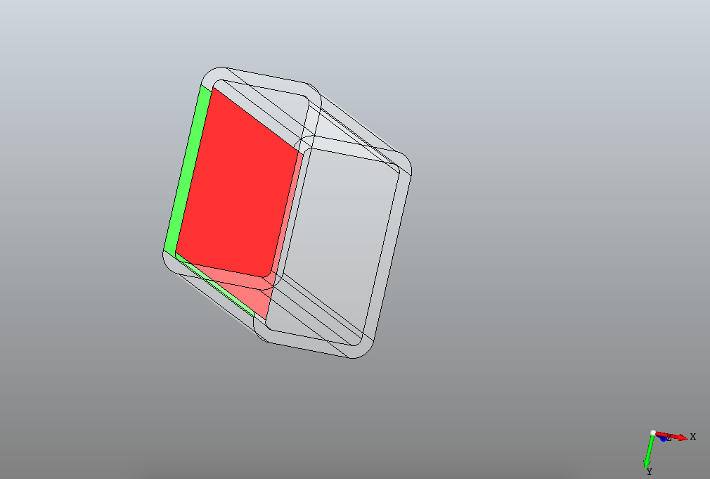

P015732_0760_003
It seems our unfolder has a problem with some of the parts in the assembly. After more thorough investigation I found our algorithm is unable to close some of the contours due to the following features in some of the parts.
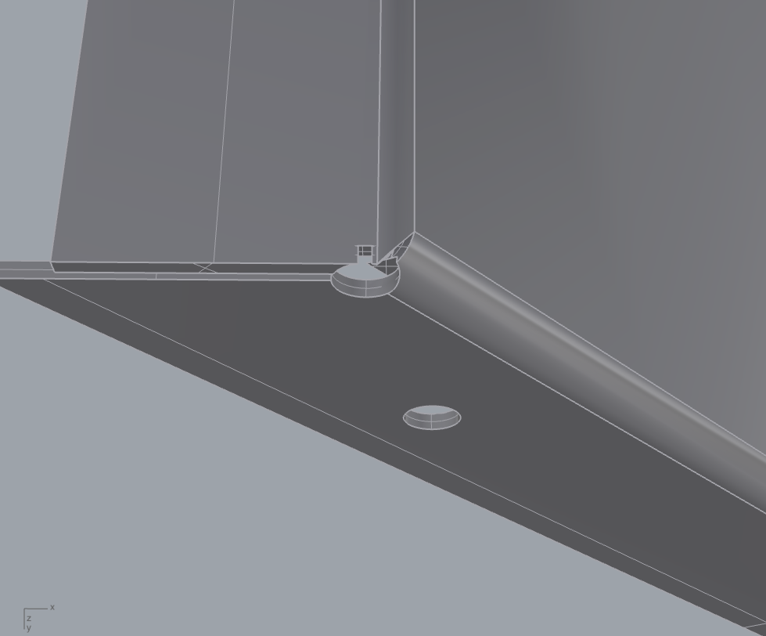

PIECE 5
Complex bend part. I will further investigate what the problem is here. At a first glance the model looks flawless.
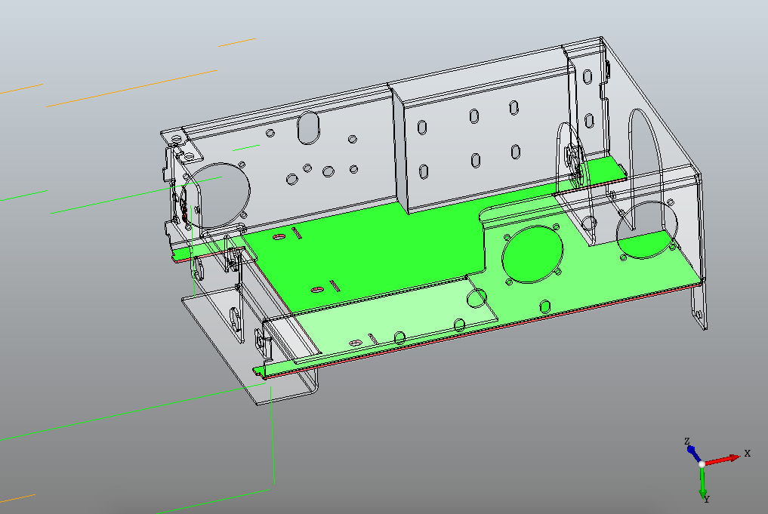

PIECE 6
Similar to PIECE 5 this will need further investigation.
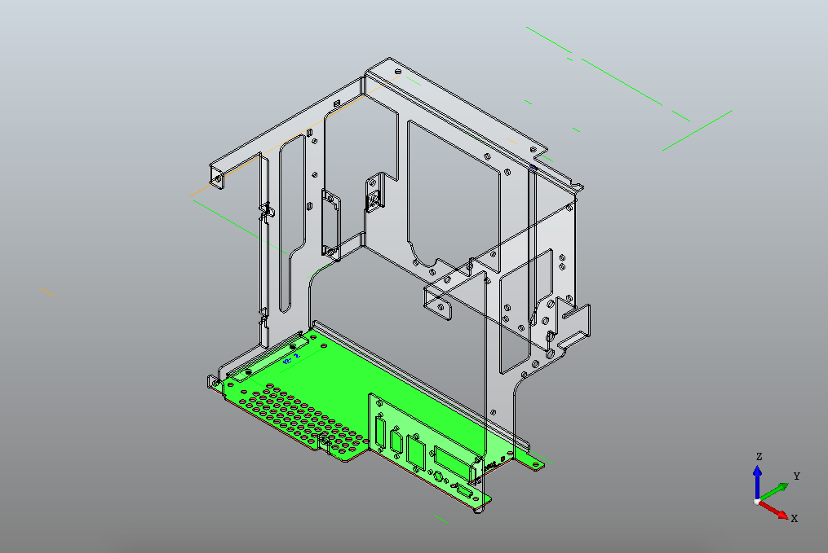

PIECE 9
Similar to 1023039 this part has a non-constant radius.
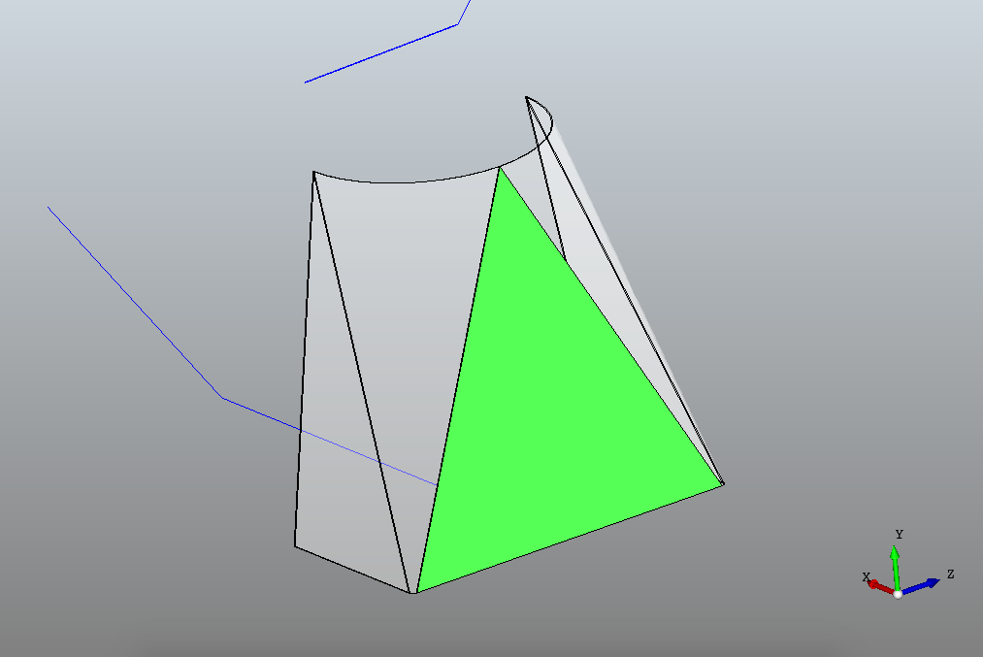

Z20610
File contains two parts the first the fiange depicted below and a part with only lines and points. The flange is currently detected correctly with the flange itself being flagged as an extrusion of height 19mm.
At the moment the volume comparison between the folded an unfolded part flags the part as error some as the difference is more than 2.5%. Moving this check to Bysoft would allow us to return geometry but indicate it as invalid. This would at least give the user something to work with.
